**Creating a Virtual Machine:**

You must create a new virtual machine (VM) where you can install CentOS 7. To do that, from the **Virtual Machines** section, click on **Create / Register VM**.

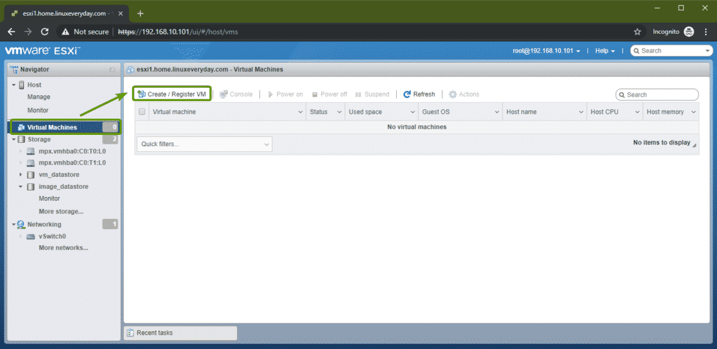

A VM creation wizard should pop up. Now, select **Create a new virtual machine**and click on **Next**.

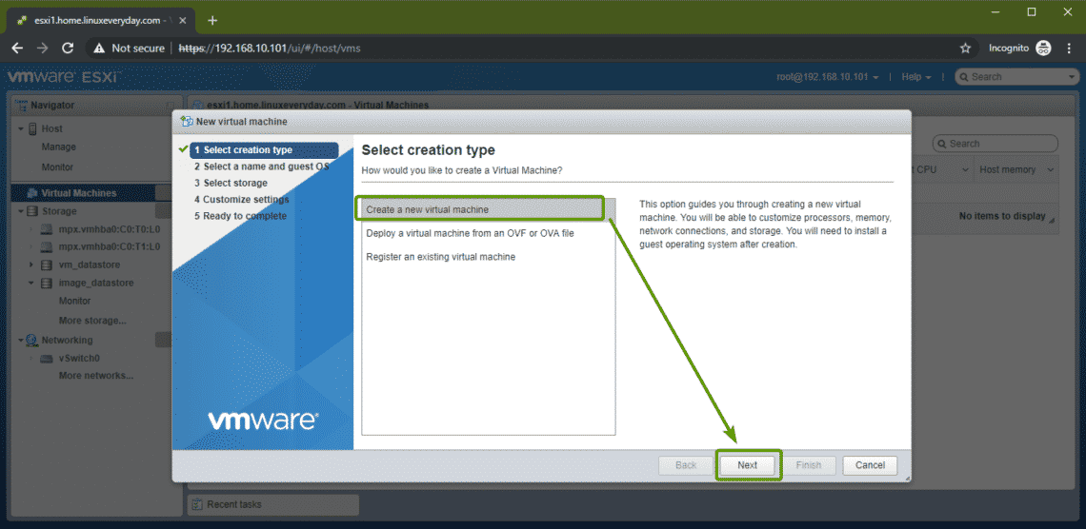

Type in a name and select **Linux** and **CentOS 7 (64-bit)** as the **Guest OS family** and **Guest OS version,** respectively.

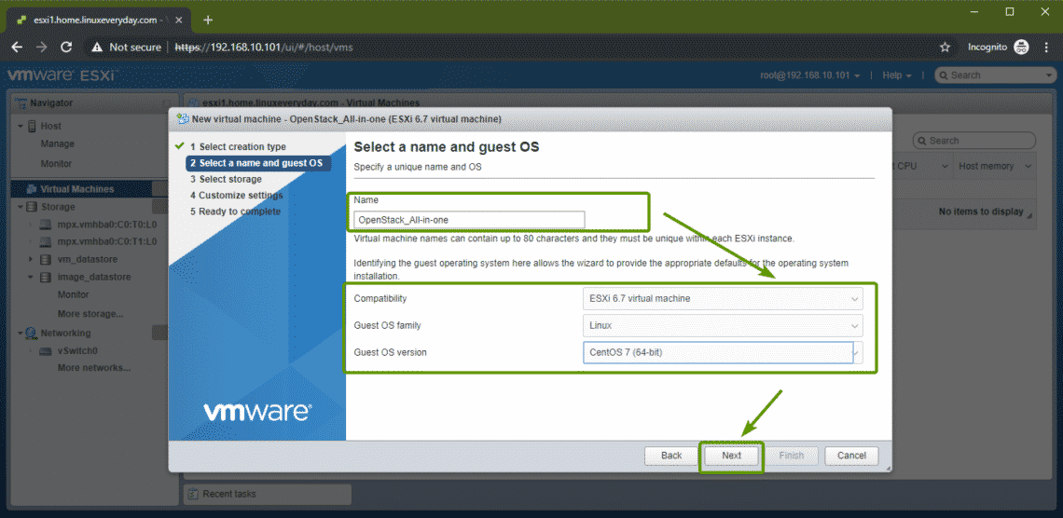

Now, select a datastore where you want to put the data of this virtual machine and click on **Next**.

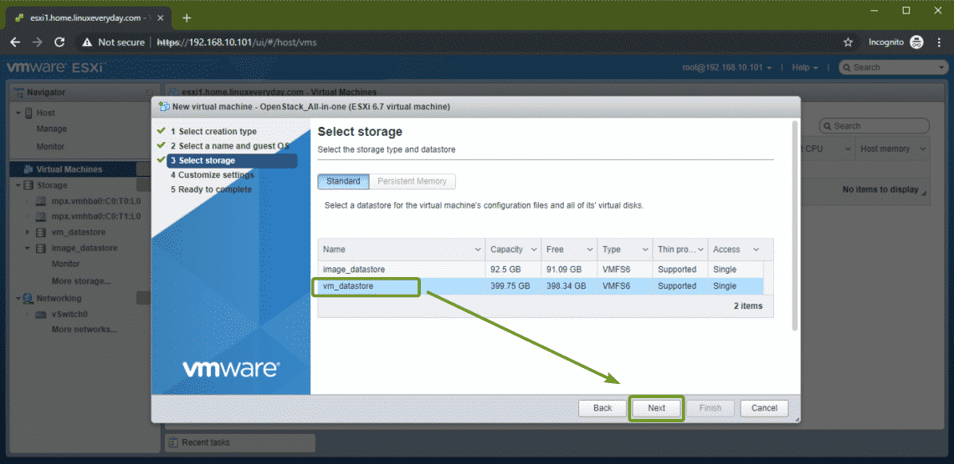

OpenStack requires about 16 GB of memory to smoothly run. So, make sure to give this VM at least 16 GB of memory. I will set the hard drive capacity to 100 GB as well. Now, select **Datastore ISO file** from the **CD/DVD Drive 1** section.

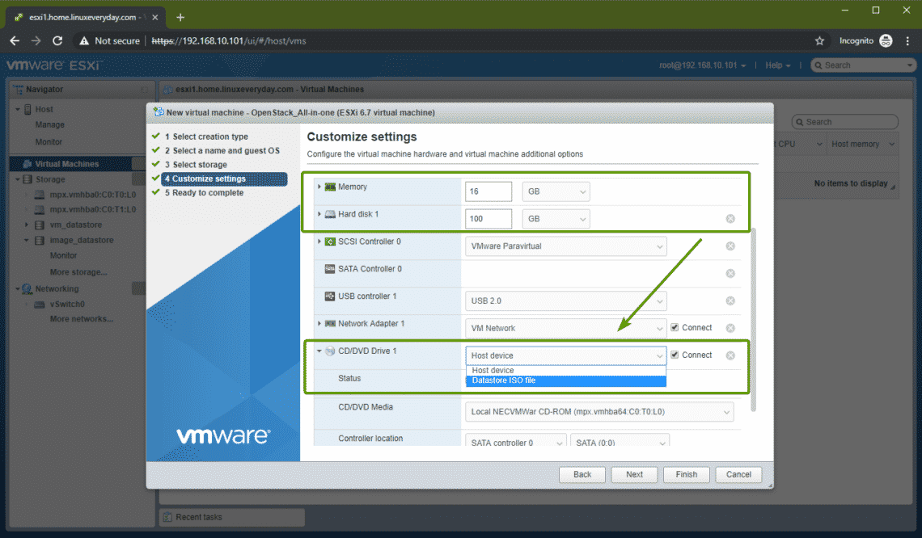

Now, select the CentOS 7 ISO image that you have just uploaded to the VMware ESXi datastore.

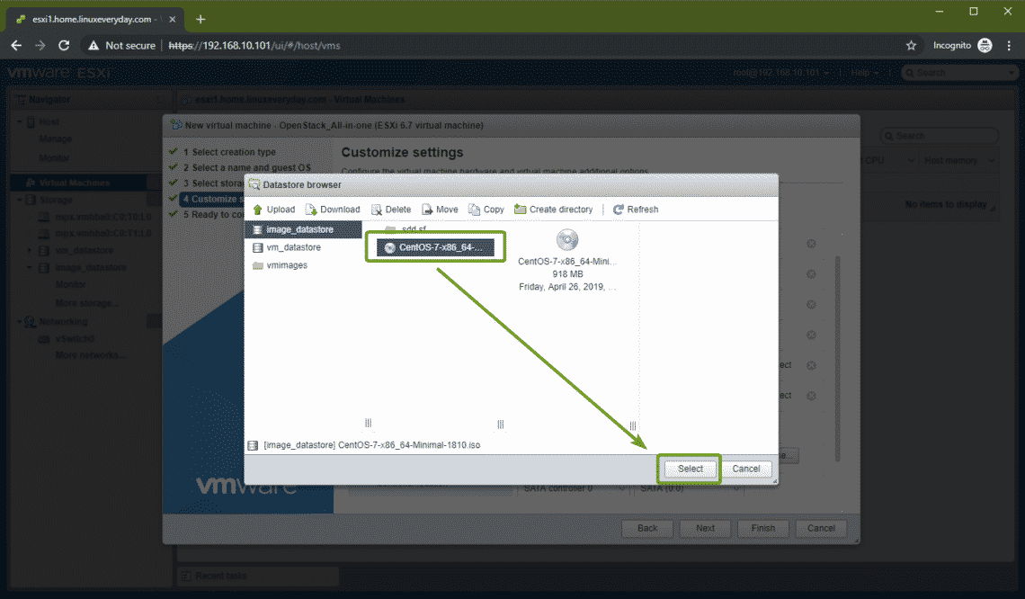

Once you’re done, click on **Finish**.

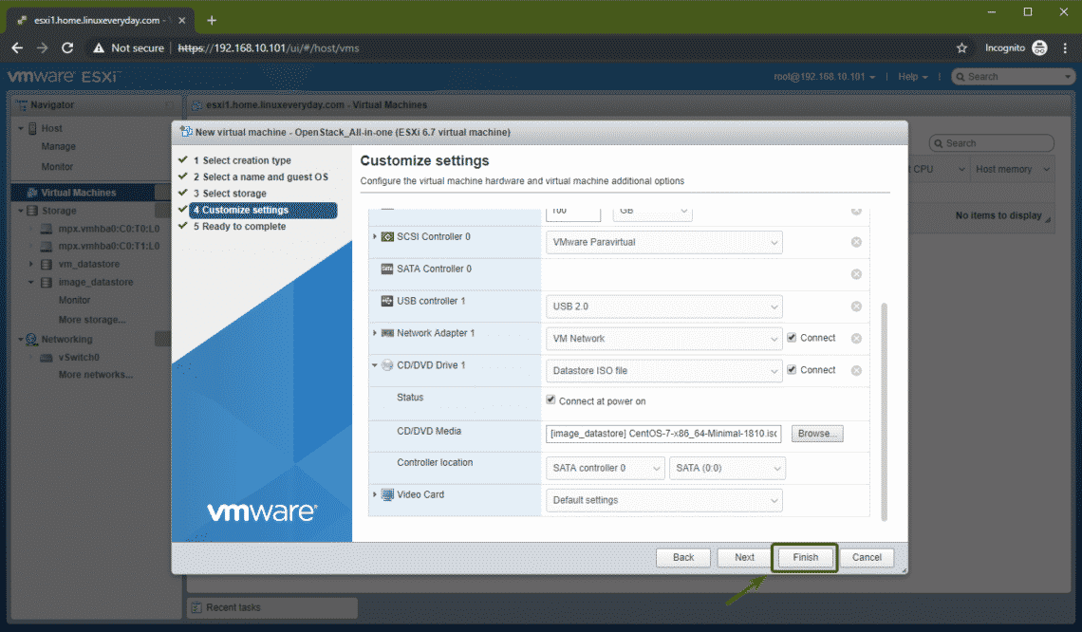

The VM should be created. Now, click on the VM.

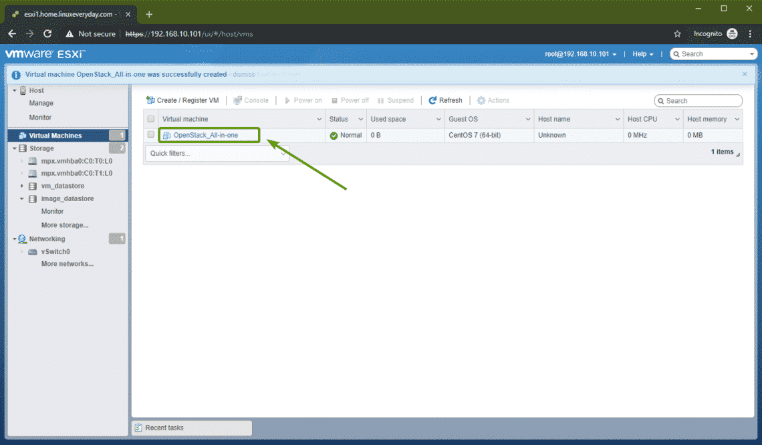

Now, click on **Edit**.

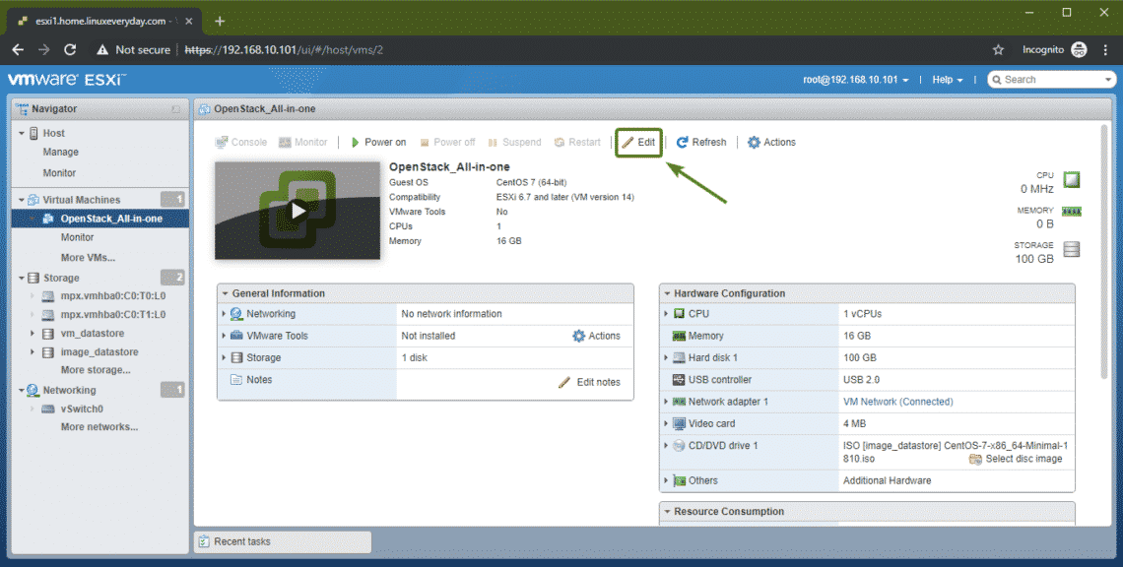

Now, you have to turn on Hardware virtualization. Otherwise OpenStack won’t perform very well as it uses KVM/QEMU as the default hypervisor. To do that, check the **Expose hardware assisted virtualization to the guest OS** from the **CPU** section. Once you’re done, click on **Save**.

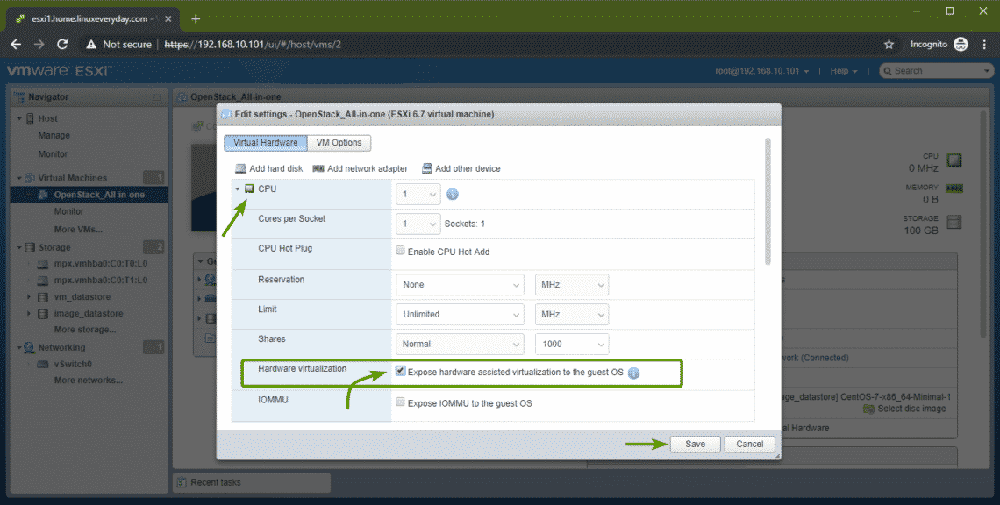

Now, you are ready to install CentOS 7 on the VM.

### Installing CentOS 7:

Now, click on **Power on** to power on the virtual machine.

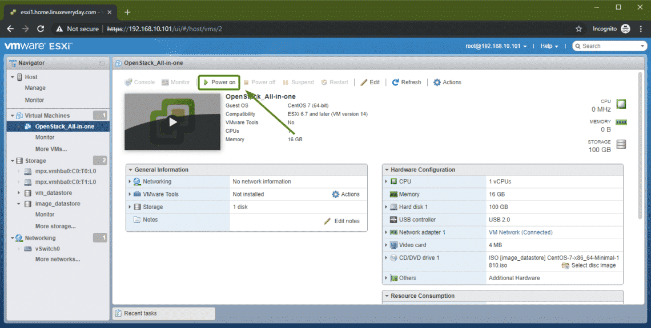

Then, click on **Console** and click on **Open browser console**.

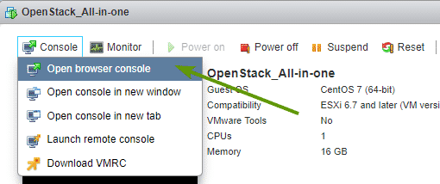

The CentOS 7 installer should boot. Select **Install CentOS 7** and press **<Enter>**.

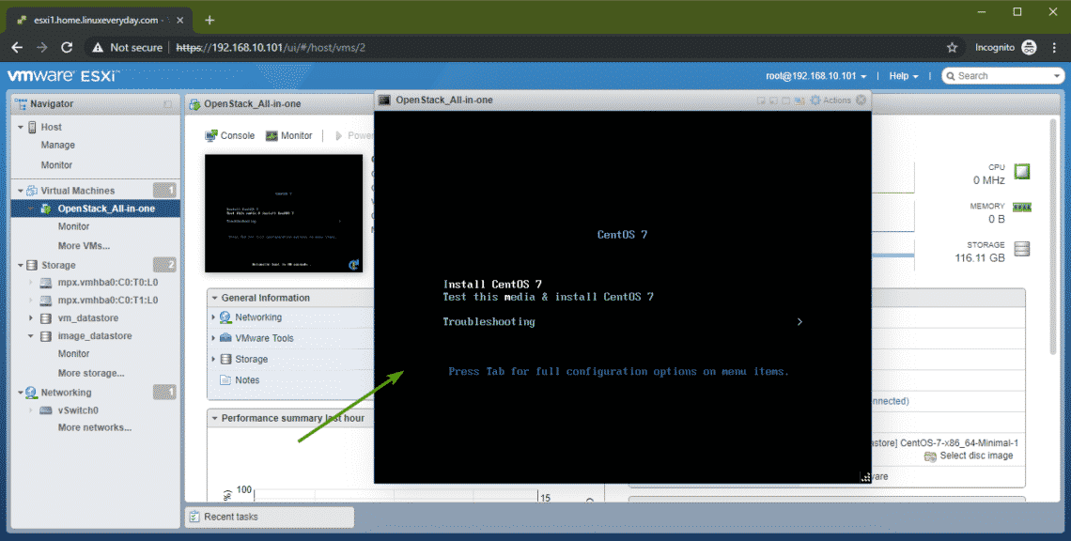

Now, install CentOS 7 on the virtual machine as usual. Make sure to set a **root** password during installation.

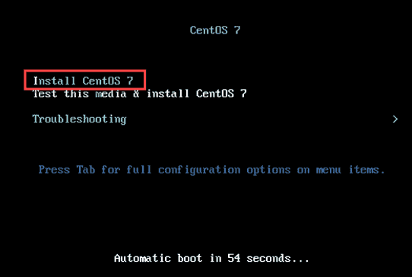

### Step 4: Install CentOS

Before starting the installation process itself, select which language you would like to use during installation. The default option is English.

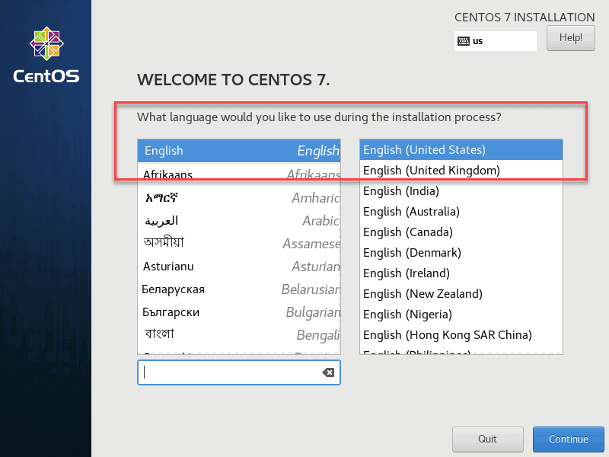

Click **Continue** to confirm your selection.

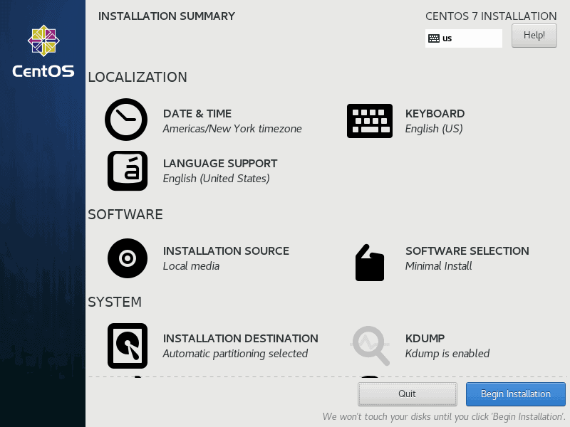

There are a couple of settings you would want to configure. All items marked with a warning icon must be configured before you begin the installation.

System configurations outlined below may differ based on use case.

#### Set Date and Time

To set a date and time for the system, click the **Date & Time**icon under the Localization heading. Select a region/time zone on the map of the world as seen below. Once you have selected your time zone, hit **Done** to save your changes.

## Select the Time zone and Date.

#### Keyboard Layout

Select the **Keyboard** option under the Localization heading to set the keyboard layout.

The system default is English (US) and the language you selected in the initial window. Click the **plus** icon to add more layouts. Move a layout to the top of the list to make it the default option.

Click the **Options** button to define a key combination for switching between keyboard layouts. When you are satisfied with the settings defined, select the **Done** button to confirm the changes.

#### System Language

Next, select the **Language Support** option under the Localization heading. The language selected in the **Welcome to CentOS 7** window will be the default system language. If necessary, select additional languages and hit the **Done** button once you are finished.

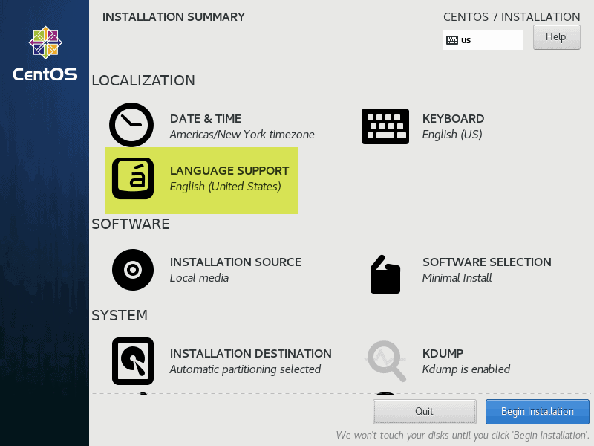

#### Software Selection

Select the Software Selection option under the Software heading. You will see a list of predefined **Base Environment**options and optional add-ons. This part entirely depends on your needs.

* **Minimal Install.** This is the most flexible and least resource-demanding option. Excellent for production environment servers. Be prepared to customize the environment.
* **Predefined Server Options.** If you are 100% certain about the role of your server and don’t want to customize it for its role, select one of the predefined server environments.
* **GNOME Desktop and KDE Plasma Workspaces.** These environments include a full graphical user interface.

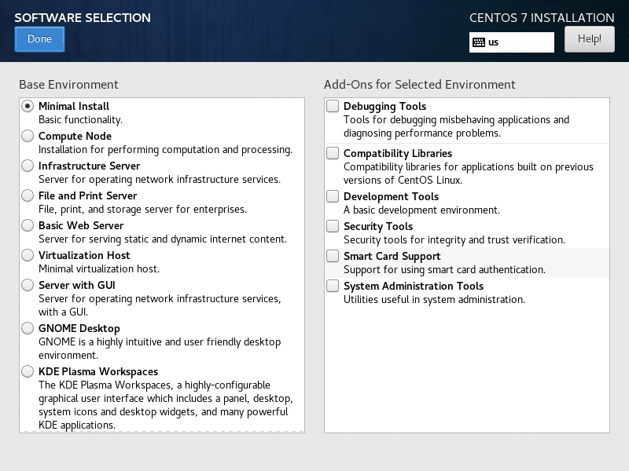

When you have selected the base environment and optional add-ons, click the **Done** button. Wait for the system to check for software dependencies before you move on to the next option.

#### Select Installation Destination

Click the **Installation Destination** option under the System heading. Check your machine’s storage under the Local Standard Disks heading. CentOS 7 will be installed on the selected disk.

**Partitioning**

**Option 1: Automatic Partitioning**

Under the Other Storage Options heading, select the **Automatically configure partitioning** checkbox. This ensures the selected destination storage disk will automatically partition with the **/(root)**, **/home** and **swap** partitions. It will automatically create an LVM logical volume in the **XFS file system**.

If you do not have enough free space, you can reclaim disk space and instruct the system to delete files.

When finished, click the **Done** button.

**Option 2: Manual Partitioning**

Select the **I will configure partitioning** checkbox and choose **Done.**

If you want to use other file systems (such as **ext4** and **vfat**) and a non-LVM partitioning scheme, such as **btrfs**. This will initiate a configuration pop-up where you can set up, you are partitioning manually.

This is an advanced option that depends on your requirements.

Network and Hostname

Click the Network & Host Name option under the System heading.

For the hostname, type in the fully qualified domain name of your system. In our example, we will [set the  **Hostname**](https://phoenixnap.com/kb/how-to-set-or-change-a-hostname-in-centos-7) as my_server.aigilx.local.

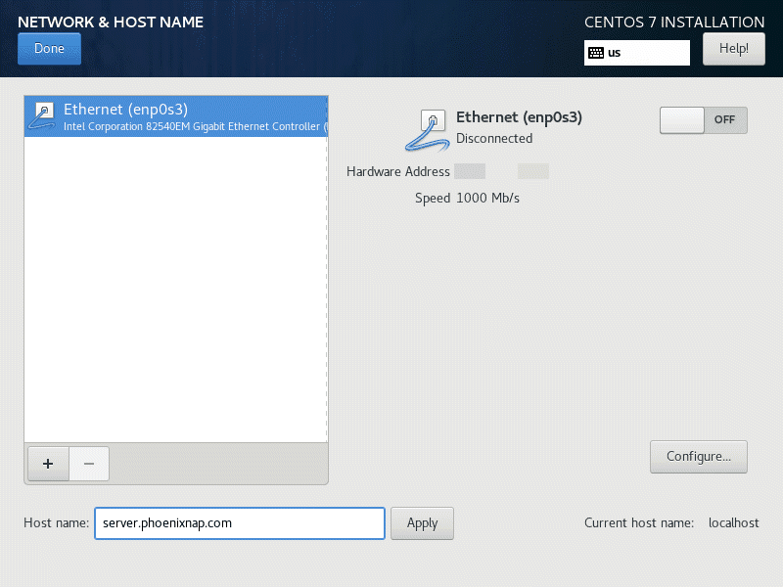

Select **Configure…** and select to add **IPv4** settings or **IPv6** settings depending on what you have. Add static IP addresses to help identify your computer on the network. Bear in mind that your network environment’s settings define these values.

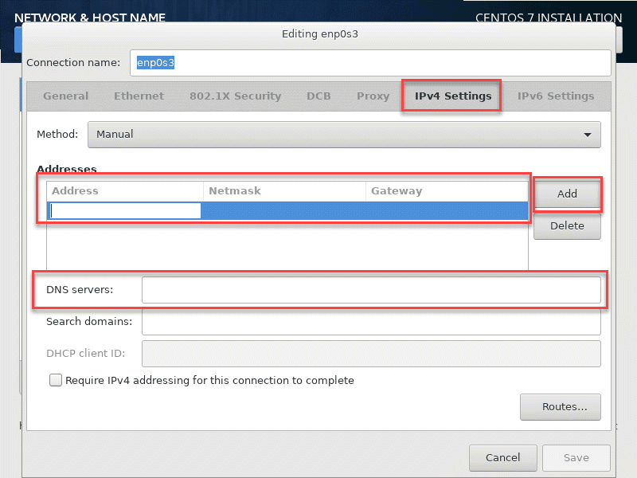

To add a static IP address:

1. Select **Manual** from the Method drop-down.
2. Click the **Add** button to add a static IP address.
3. Enter the information for your network domain.
   * IP Address **172.16.10.1 to 172.16.10.254**
   * Netmask Address **255.255.255.0**
   * Gateway Address **172.16.10.1**
   * DNS Servers Address **172.16.10.10 172.19.40.50**
4. Click **Save** to confirm your changes.

#### Start the Installation Process

Once everything is set up according to your liking, hit **Begin Installation** to start the install. This will start the initial installation process.

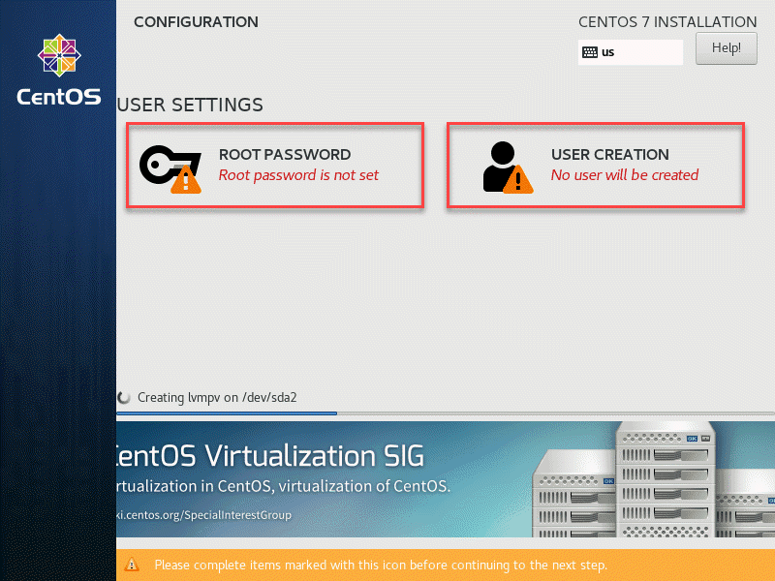

#### Define Root Password

To define the root user, select the **Root Password** icon.

Select a **Root Password** and re-enter it in **Confirm** field.

Root user accounts should consist of at least 12 characters, including uppercase and lowercase letters, numbers, and special characters. We cannot stress enough the importance of a well-defined root password.

Click the **Done** button to proceed.

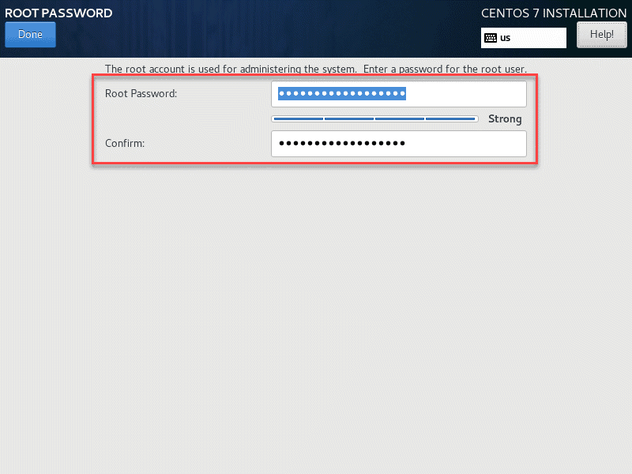

#### Create User

To begin, select the **User Creation** option.

Add a new system account user by defining the **full name**, **username**, and **password**. We recommend you check the **Make this user administrator** and **Require a password to use this account** checkboxes. This will grant the user root privileges.

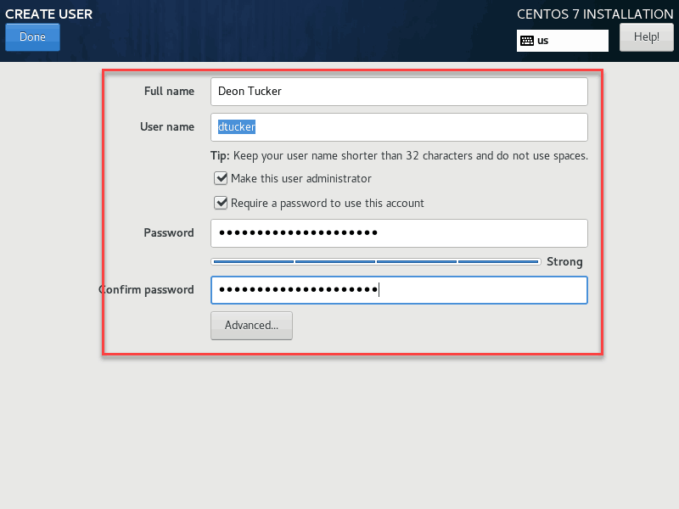

After you fill in all the fields and define a **secure password**, select **Done** in the upper-left corner of the screen.

Wait for the installation process to complete.

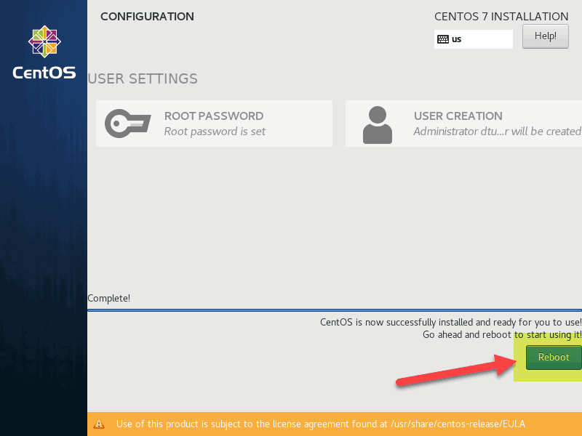

Before you start using your new CentOS installation, reboot the system. Click the **Reboot** button.

Log into the system by using the credentials you defined previously.